**Crying in the Chapel –**

**Elvis-kerkdienst**

**De Flambou**

**Surhuisterveen**

**25 mei 2025**

**Voorganger: ds. Fred Omvlee**

**Ouderling van dienst: Henk Stienstra**

**Piano: Johan Timersma**

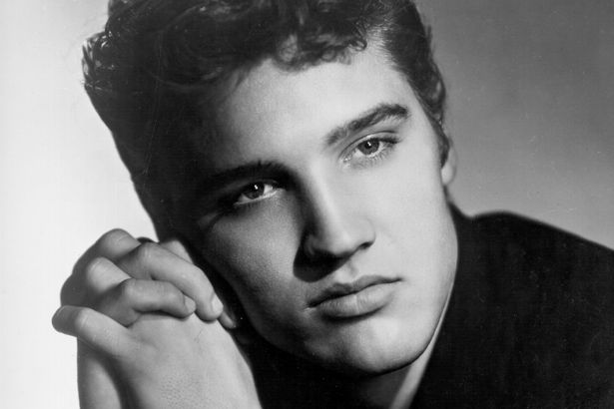

**Welkom**

**Samenzang: Can’t help falling in love**

Wise men say only fools rush in  
But I can't help falling in love with you  
Shall I stay?  
Would it be a sin  
If I can't help falling in love with you?Like a river flows surely to the sea  
Darling so it goes  
Some things are meant to be  
Take my hand, take my whole life too  
For I can't help falling in love with you

Like a river flows surely to the sea  
Darling so it goes  
Some things are meant to be  
Take my hand, take my whole life too  
For I can't help falling in love with you  
For I can't help falling in love with you

**Even voorstellen: dominee Fred Omvlee**

**De jeugd van Elvis**

**-Peace in the Valley**

(Nu heb ik het moeilijk, Heer, maar eens zal er vrede zijn in de vallei voor mij, als de leeuw zal neerliggen bij het lam en de wilde dieren geleid worden door een kind)

**Bijbellezing: Psalm 11 – Bijbel Elvis**

**Het leven van Elvis in de sixties**

**Samenzang: Crying in the Chapel**

You saw me crying in the chapel  
The tears I shed were tears of joy  
I know the meaning of contentment  
I am happy with the Lord

Just a plain and simple chapel  
Where all bumble people go to pray  
I prayed the Lord that I'll grow stronger  
As I live from day to day

I searched (I searched) and I searched (I searched) but I couldn't find  
No way on earth to gain peace of mind

Now I'm happy in the chapel  
Where people are of one accord (One accord)  
Yes, we gather in the chapel  
Just to sing and praise the Lord

You'll search and you'll search but you'll never find  
No way on earth to find peace of mind

Take your troubles to the chapel  
Get down on your knees and pray  
Then your burdens will be lighter  
And you'll surely find the way (and you'll surely find the way)

**1968-1977: het einde van Elvis’ leven**

**Overdenking: Levenslessen van E.L.V.I.S…**

**Samenzang: Amazing Grace**

Amazing Grace!  
How sweet the sound  
That saved a wretch like me  
I once was lost but now am found  
Was blind but now I seeWhen we've been there ten thousand years  
Bright shining as the sun  
We've no less days to sing God's praise  
Than when we've first begun

Through many dangers, toils and snares  
I have already come  
'Tis Grace has brought me safe thus far  
And Grace will lead me home

Amazing Grace!  
How sweet the sound  
That saved a wretch like me  
I once was lost but now am found  
Was blind but now I see  
Was blind but now I see

**Gebeden**

**Collecte**

**How Great Thou Art**

Oh Lord my God, when I in awesome wonder

Consider all the worlds thy hands have made

I see the stars, I hear the rolling thunder

Thy power throughout the universe displayed

(When Christ shall come with shout of acclamation)

(And take me home, what joy shall fill my heart)

Then I shall bow in humble adoration

And there proclaim my God how great thou art

Then sings my soul my savior God to thee

How great thou art (how great thou art)

How great thou art (how great thou art)

Then sings my soul my savior God to thee

How great thou art

**Reiszegen**

**Samenzang: If The Lord wasn’t walking by my side**

I don't know just what I'd do  
If the Lord wasn't walking by my side  
When I was drifting (on the sea of despair)  
And I was wondering (if Jehovah's up there)   
When Jesus found me, (in my sinful life)  
He heard me praying (on my knees at night)  
Now I'm singing (Now I'm singing this happy song)  
Because I'm happy (because I'm happy as I go along)  
And I don't know (I don't know) just what I'd do  
If the Lord wasn't walking by my side  
What would I do, (What would I do when a tear fills my eyes)  
What would I do (What would I do when it's my time to die)  
Well I'd be lonely, discouraged  
Burdened on the way  
If the Lord wasn't walking by my side every day

I'd be so friendless (I'd be friendless all alone and blue)  
And I'd be helpless (I'd be helpless, wouldn't know what to do)  
And I don't know (I don't know) just what I'd do  
If the Lord wasn't walking by my side

What would I do when the tears fill my eyes  
(What would I do) What would I do when it's my time to die  
(I'd be lonely, discouraged, burdened on the way)  
If the Lord wasn't walking by my side every day

I'd be so friendless, (I'd be friendless all alone and blue)  
I'd be so helpless (I'd be helpless, wouldn't know what to do)  
And I don't know (I don't know) just what I'd do  
If the Lord wasn't walking by my side every day If the Lord (wasn't walking) wasn't walking by my side

**Wil je reageren of contact?**

Mail: [fredomvlee@gmail.com](mailto:fredomvlee@gmail.com)

Of via @fredomvlee op Instagram, TikTok, Facebook en via

[www.elviskapel.nl](http://www.elviskapel.nl)